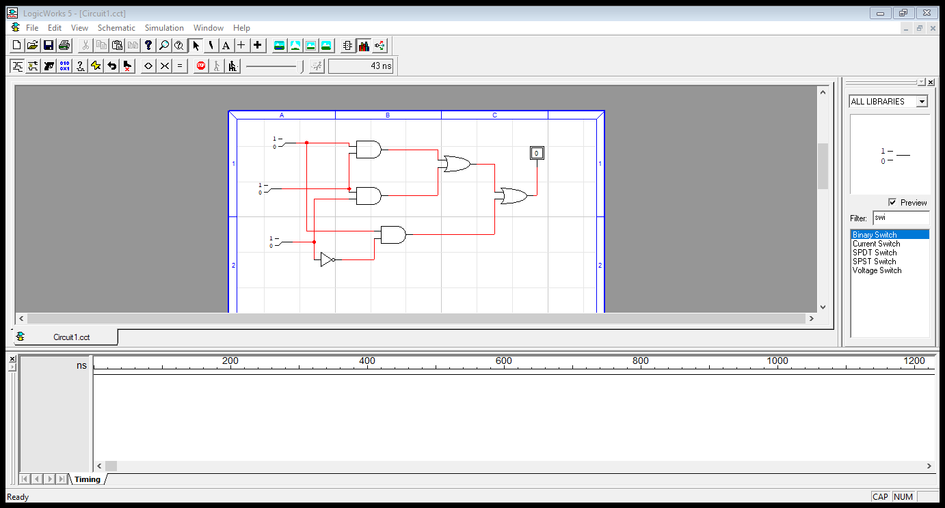**Roll no: 20k-0409**

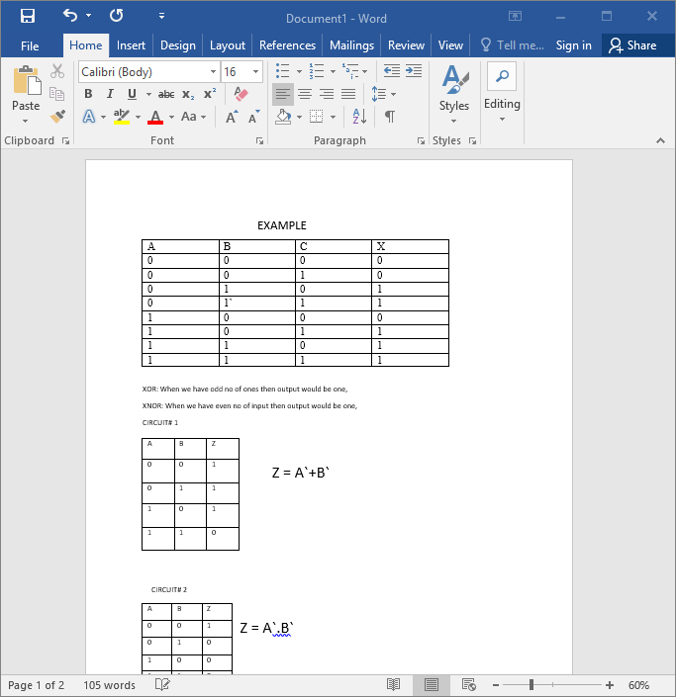**Name: MUKAND KRISHNA**

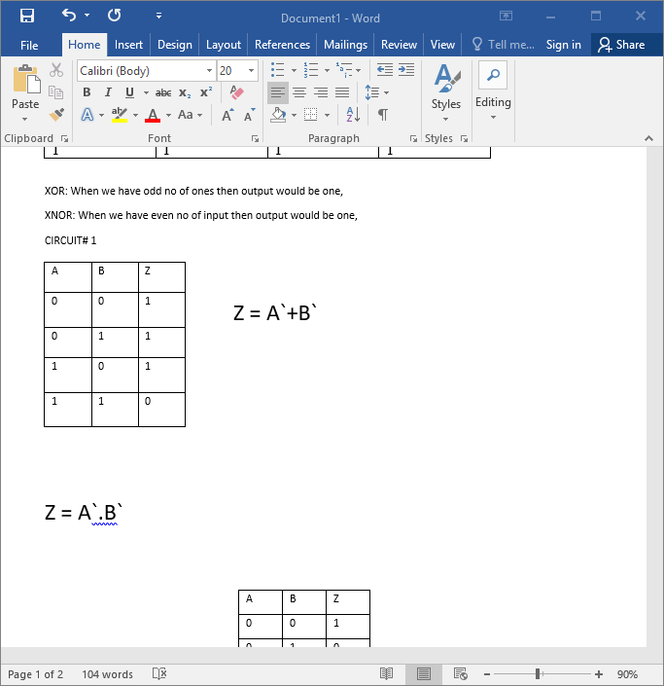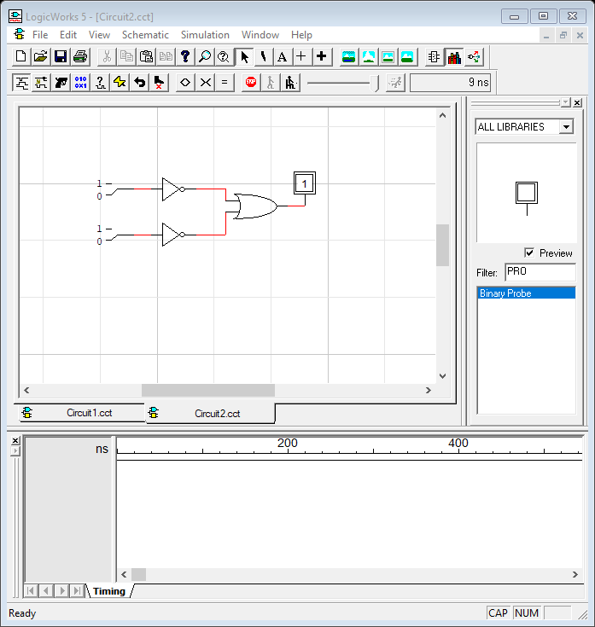

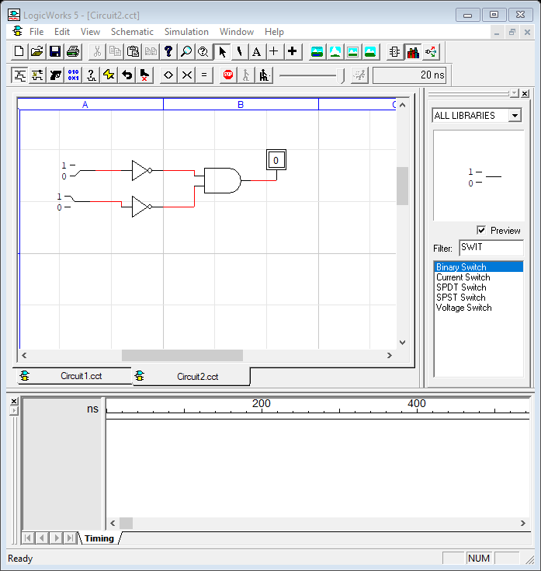

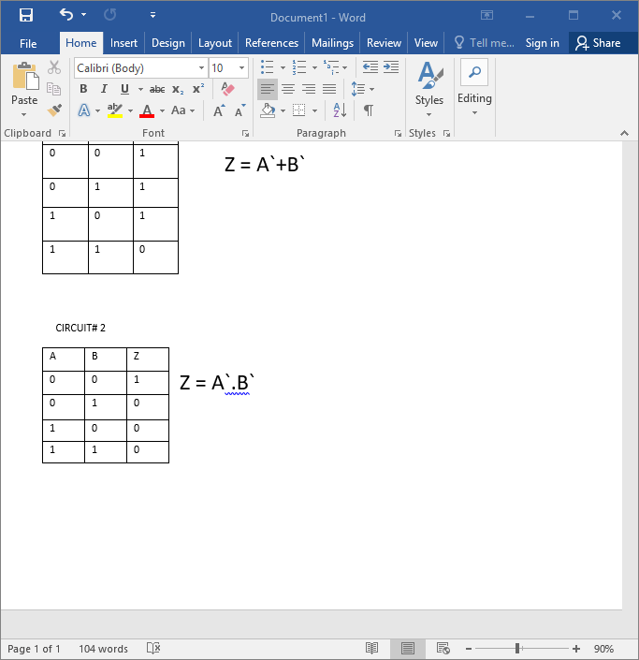

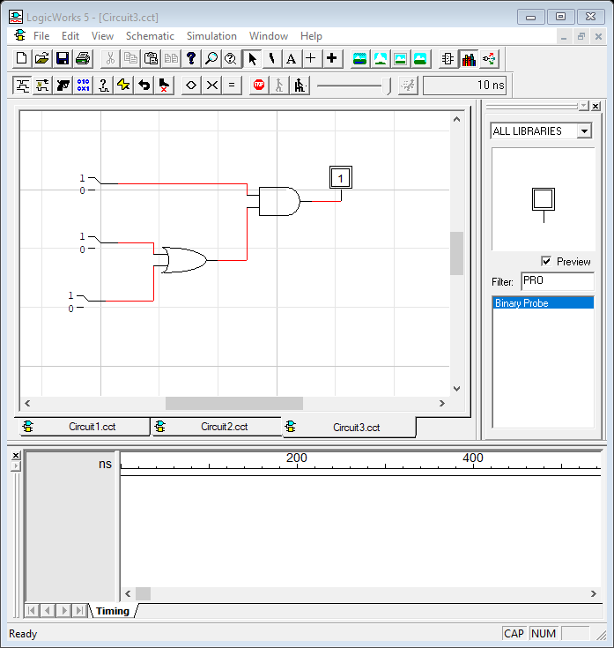

**CIRCUIT#3**

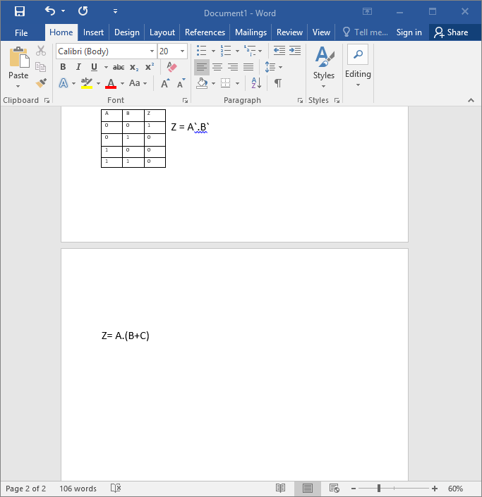

Boolean Expression:

**CIRCUIT# 4 CIRCUIT# 5**

BOOLEAN EXPRESSION: Z = A+(B.C) EXPRESSION: Z = (A.B) + (A.C)

**CIRCUIT# 6**  **CIRCUIT# 7**

EXPRESSION: Z = (A.B).B` EXPRESSION: Z = (A.B) + (C.D)

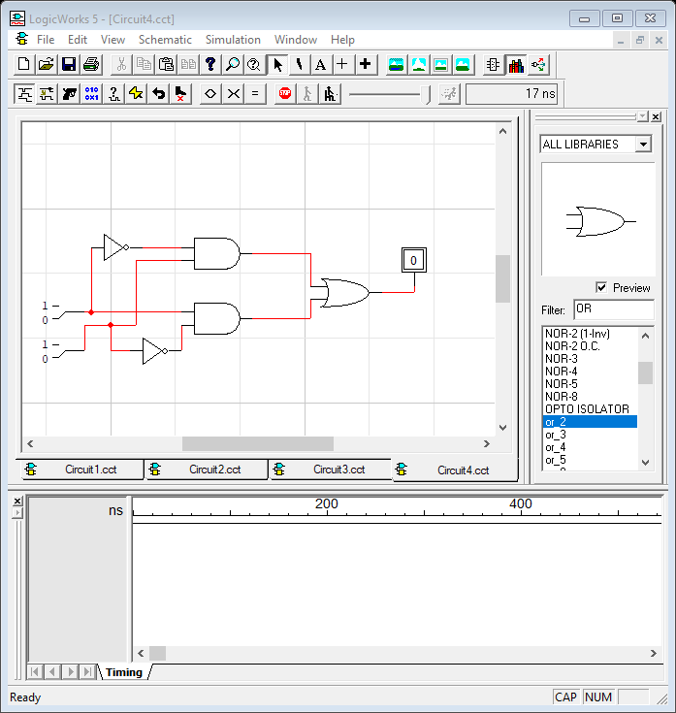

**CIRCUIT# 8 --------->>>>**

EXPRESSION: Z = (A.B`) + (A`.B)

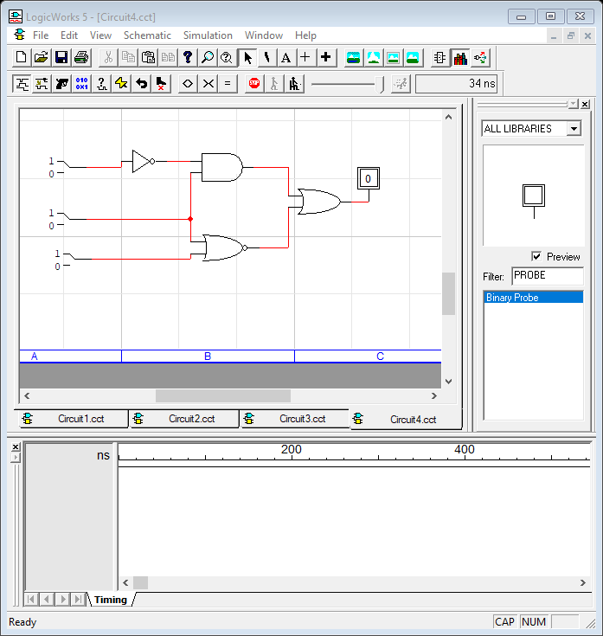

**LOGIC CIRCUIT DIAGRAM**

EXPRESSION: Z = (A~. B) + (B+C) ~

|  |  |  |  |
| --- | --- | --- | --- |
| **A** | **B** | **C** | **X** |
| 0 | 0 | 0 | 1 |
| 0 | 0 | 1 | 0 |
| 0 | 1 | 0 | 1 |
| 0 | 1 | 1 | 1 |
| 1 | 0 | 0 | 1 |
| 1 | 0 | 1 | 1 |
| 1 | 1 | 0 | 0 |
| 1 | 1 | 1 | 0 |

**COMMUTATIVE LAW**

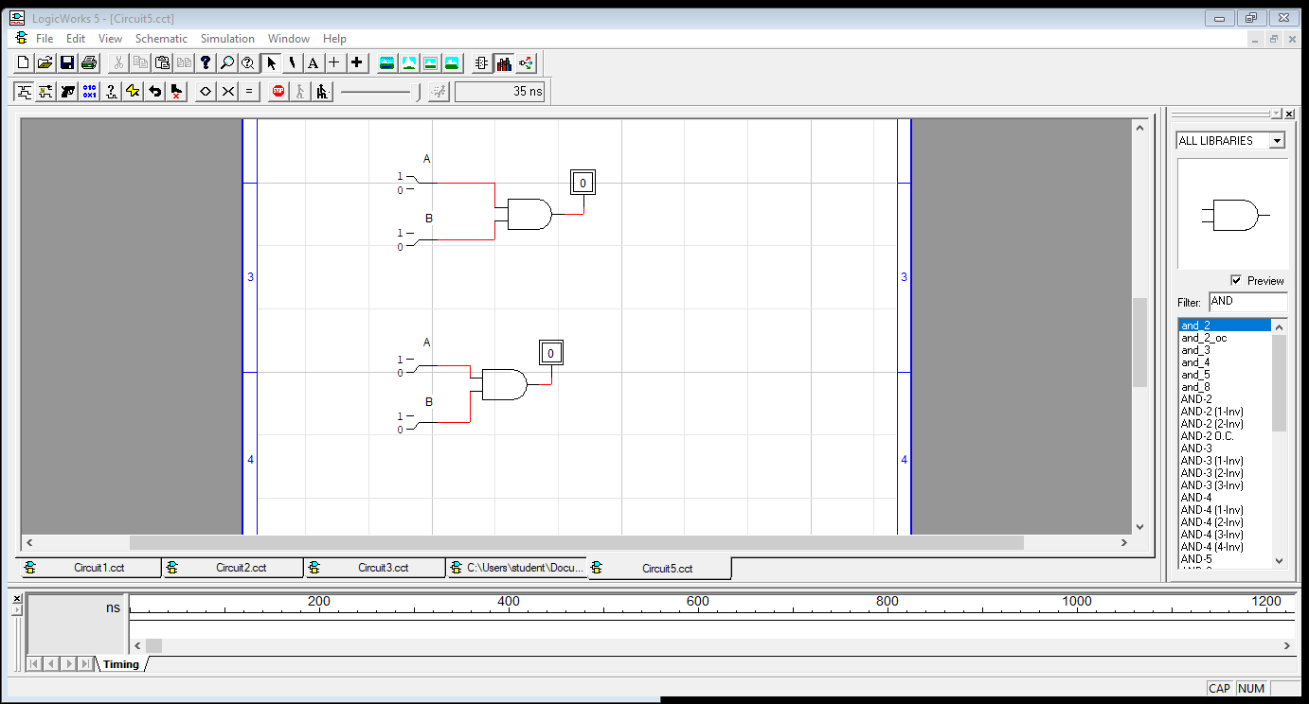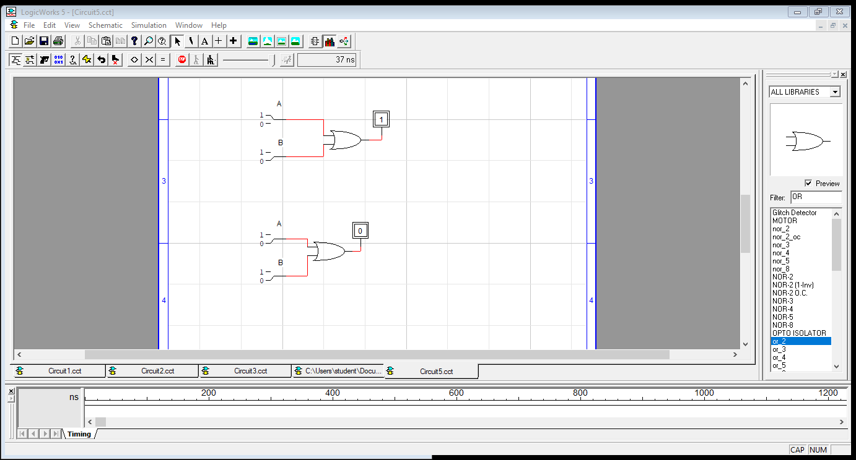 **ADDITION**: a + b = b+a **MULTIPLICATION**: ab = b.a

|  |  |  |  |  |  |
| --- | --- | --- | --- | --- | --- |
| A | B | A.B | A | B | A.B |
| 0 | 0 | 0 | 0 | 0 | 0 |
| 0 | 1 | 0 | 0 | 1 | 0 |
| 1 | 0 | 0 | 1 | 0 | 0 |
| 1 | 1 | 1 | 1 | 1 | 1 |

|  |  |  |  |  |  |
| --- | --- | --- | --- | --- | --- |
| A | B | A+B | A | B | B+A |
| 0 | 0 | 0 | 0 | 0 | 0 |
| 0 | 1 | 1 | 0 | 1 | 1 |
| 1 | 0 | 1 | 1 | 0 | 1 |
| 1 | 1 | 1 | 1 | 1 | 1 |

**Associative law**

**ADDITION:** a + (b + c) = (a + b) + c **MULTIPLICATION**: a(bc) = (a.b)c

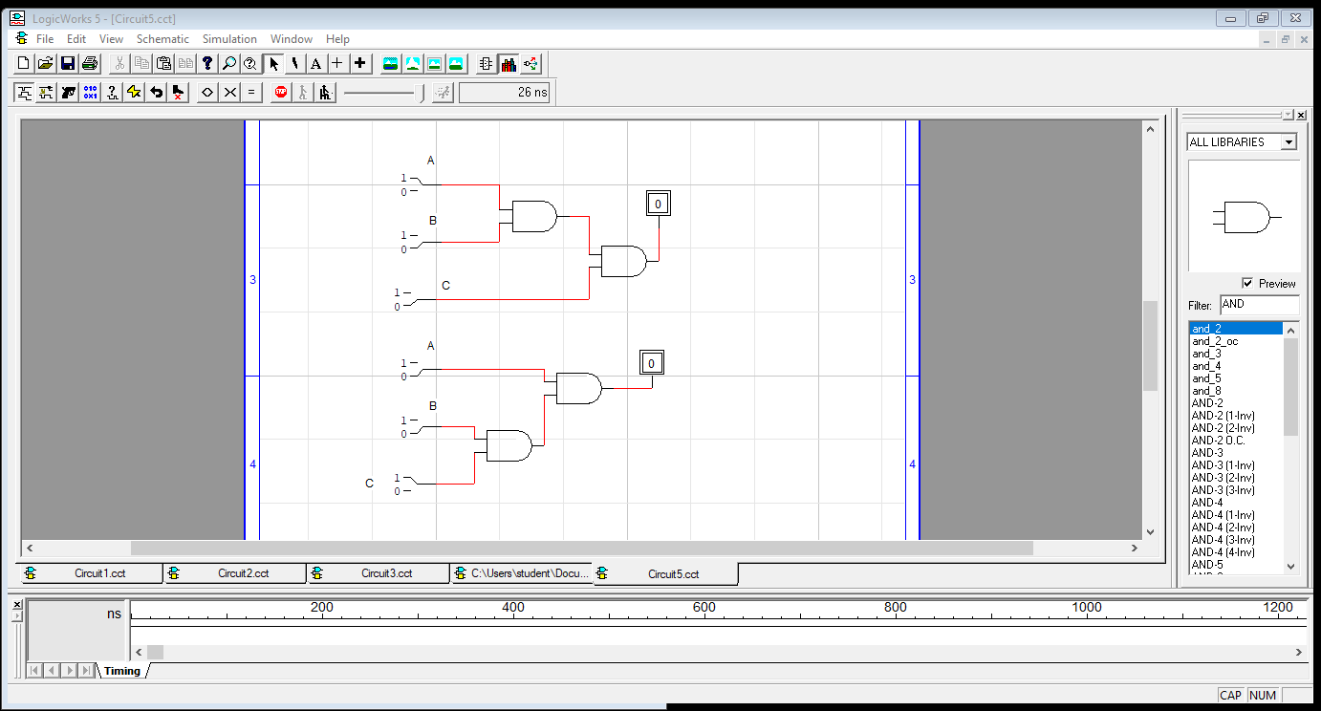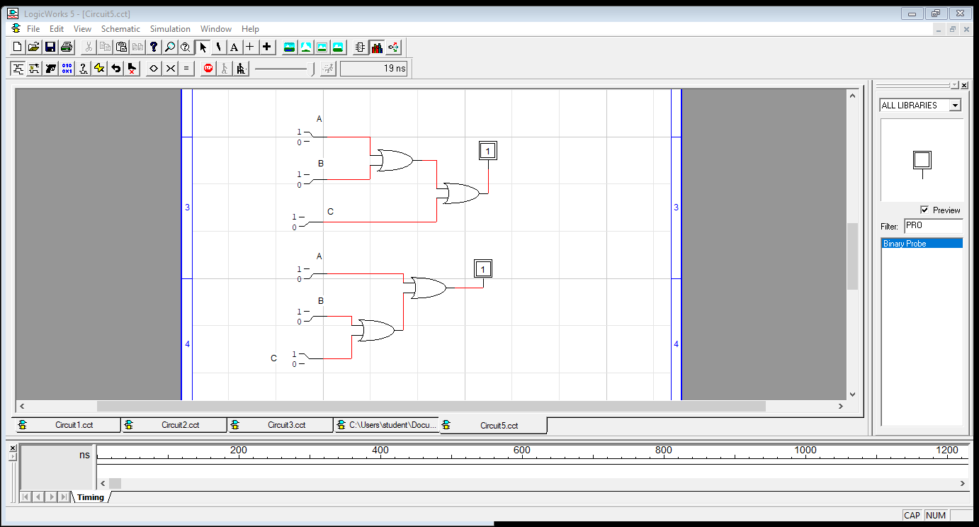

|  |  |  |  |  |  |  |  |
| --- | --- | --- | --- | --- | --- | --- | --- |
| A | B | C | (a+b)+c | A | B | C | a+(b+c) |
| 0 | 0 | 0 | 0 | 0 | 0 | 0 | 0 |
| 0 | 0 | 1 | 1 | 0 | 0 | 1 | 1 |
| 0 | 1 | 0 | 1 | 0 | 1 | 0 | 1 |
| 0 | 1 | 1 | 1 | 0 | 1 | 1 | 1 |
| 1 | 0 | 0 | 1 | 1 | 0 | 0 | 1 |
| 1 | 0 | 1 | 1 | 1 | 0 | 1 | 1 |
| 1 | 1 | 0 | 1 | 1 | 1 | 0 | 1 |
| 1 | 1 | 1 | 1 | 1 | 1 | 1 | 1 |

|  |  |  |  |  |  |  |  |
| --- | --- | --- | --- | --- | --- | --- | --- |
| A | B | C | (a.b).c | A | B | C | (a.b)c |
| 0 | 0 | 0 | 0 | 0 | 0 | 0 | 0 |
| 0 | 0 | 1 | 0 | 0 | 0 | 1 | 0 |
| 0 | 1 | 0 | 0 | 0 | 1 | 0 | 0 |
| 0 | 1 | 1 | 0 | 0 | 1 | 1 | 0 |
| 1 | 0 | 0 | 0 | 1 | 0 | 0 | 0 |
| 1 | 0 | 1 | 0 | 1 | 0 | 1 | 0 |
| 1 | 1 | 0 | 0 | 1 | 1 | 0 | 0 |
| 1 | 1 | 1 | 1 | 1 | 1 | 1 | 1 |

***Distributive Law***

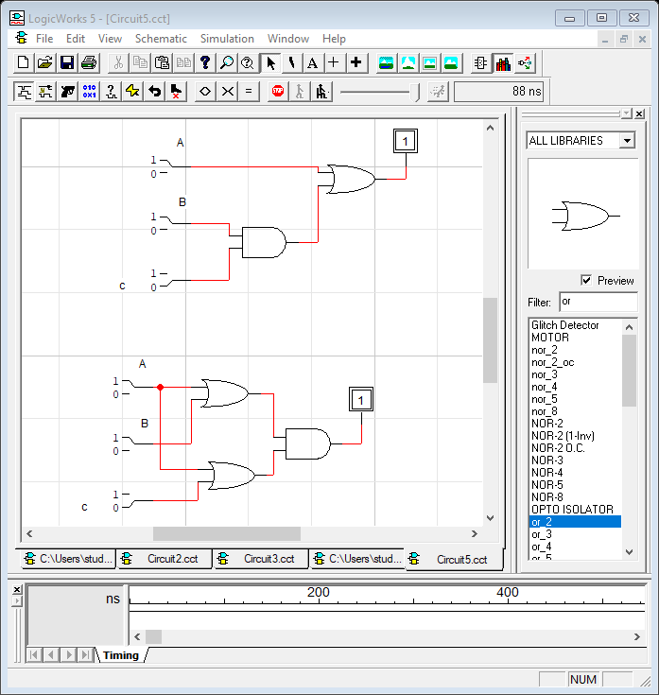**Addition:** A+(B+C) = (A+B)+(A+C) **Multiplication**: A+(B.C)=(A+B).(A+C)

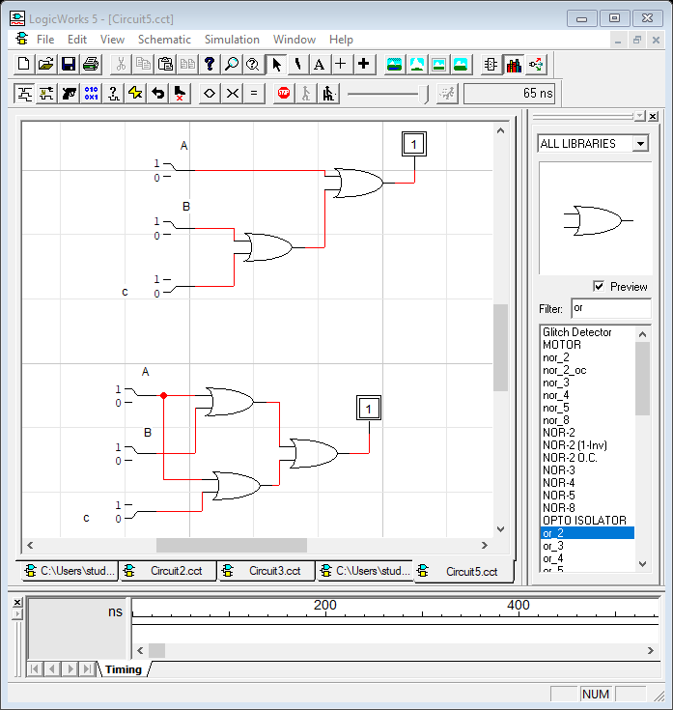

|  |  |  |  |  |  |  |  |
| --- | --- | --- | --- | --- | --- | --- | --- |
| A | B | C | A+(B.C) | A | B | C | (A+B)**.**(A+C) |
| 0 | 0 | 0 | 0 | 0 | 0 | 0 | 0 |
| 0 | 0 | 1 | 0 | 0 | 0 | 1 | 0 |
| 0 | 1 | 0 | 0 | 0 | 1 | 0 | 0 |
| 0 | 1 | 1 | 1 | 0 | 1 | 1 | 1 |
| 1 | 0 | 0 | 1 | 1 | 0 | 0 | 1 |
| 1 | 0 | 1 | 1 | 1 | 0 | 1 | 1 |
| 1 | 1 | 0 | 1 | 1 | 1 | 0 | 1 |
| 1 | 1 | 1 | 1 | 1 | 1 | 1 | 1 |

|  |  |  |  |  |  |  |  |
| --- | --- | --- | --- | --- | --- | --- | --- |
| A | B | C | A+(B+C) | A | B | C | (A+B)+(A+C) |
| 0 | 0 | 0 | 0 | 0 | 0 | 0 | 0 |
| 0 | 0 | 1 | 1 | 0 | 0 | 1 | 1 |
| 0 | 1 | 0 | 1 | 0 | 1 | 0 | 1 |
| 0 | 1 | 1 | 1 | 0 | 1 | 1 | 1 |
| 1 | 0 | 0 | 1 | 1 | 0 | 0 | 1 |
| 1 | 0 | 1 | 1 | 1 | 0 | 1 | 1 |
| 1 | 1 | 0 | 1 | 1 | 1 | 0 | 1 |
| 1 | 1 | 1 | 1 | 1 | 1 | 1 | 1 |

**Lab# 3 tasks**

**1**. Design 3 input XOR and XNOR gate. Truth table, draw the circuit diagram.

**Truth Table Circuit diagram of XOR gate** using **and, or gate**

|  |  |  |  |
| --- | --- | --- | --- |
| A | B | C | X |
| 0 | 0 | 0 | 0 |
| 0 | 0 | 1 | 1 |
| 0 | 1 | 0 | 1 |
| 0 | 1 | 1 | 0 |
| 1 | 0 | 0 | 1 |
| 1 | 0 | 1 | 0 |
| 1 | 1 | 0 | 0 |
| 1 | 1 | 1 | 1 |

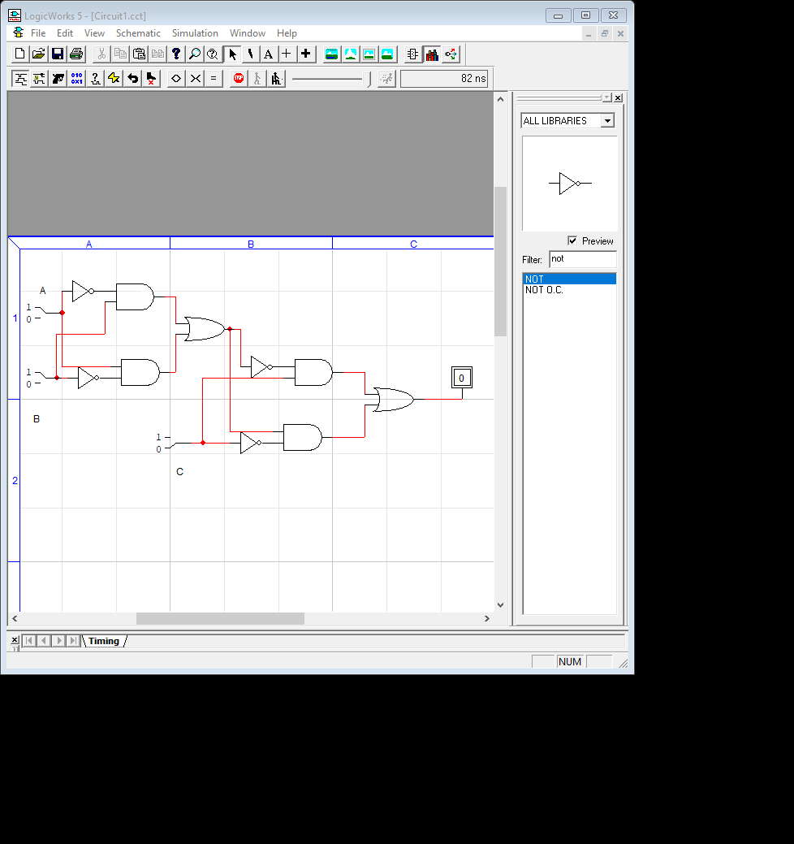

Boolean Expression: X = ABC + A`B`C + AB`C` + A`BC`

|  |  |  |  |
| --- | --- | --- | --- |
| A | B | C | X |
| 0 | 0 | 0 | 1 |
| 0 | 0 | 1 | 0 |
| 0 | 1 | 0 | 0 |
| 0 | 1 | 1 | 1 |
| 1 | 0 | 0 | 0 |
| 1 | 0 | 1 | 1 |
| 1 | 1 | 0 | 1 |
| 1 | 1 | 1 | 0 |

**Truth Table Circuit diagram of XNOR gate** using **and, or gate**

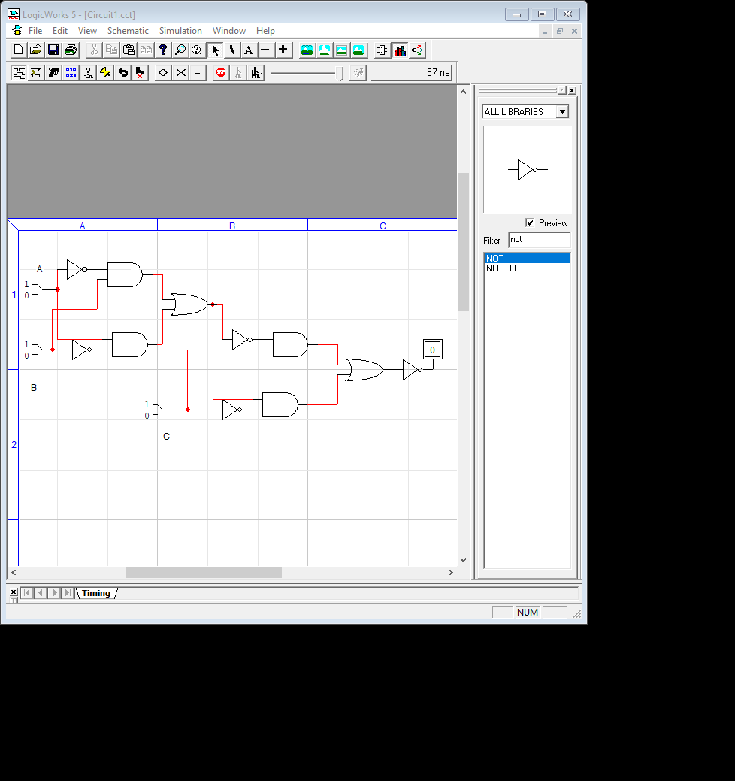

Boolean Expression: X = (ABC + A`B`C + AB`C` + A`BC`)~

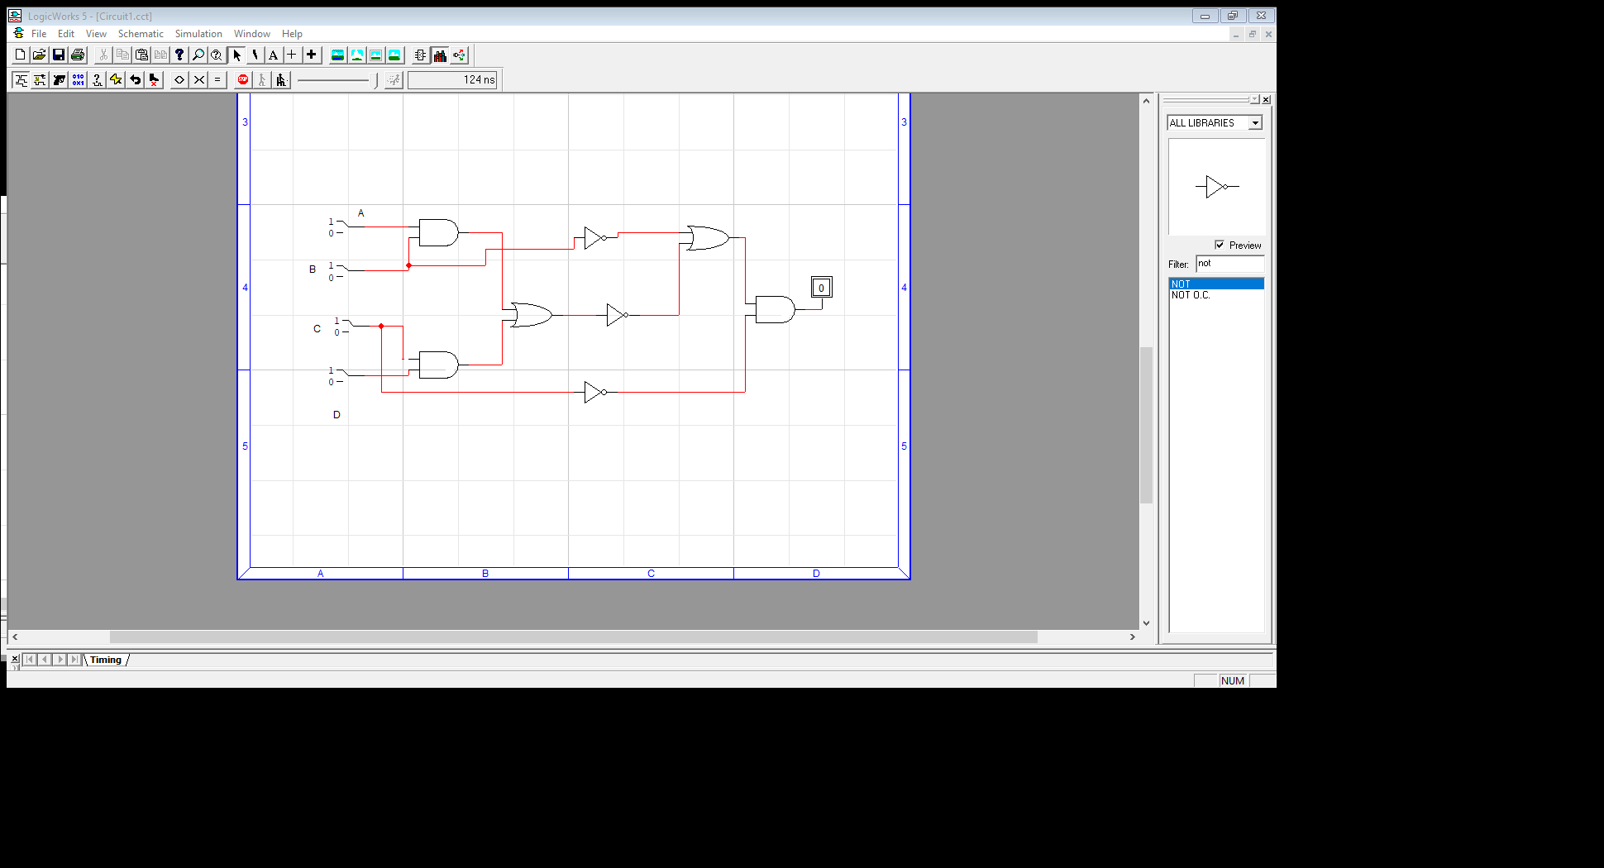**2.** Implement the following logic circuit on logic trainer, and write Boolean Expression.

Boolean Expression: X = (A.B)+(C.D)~+B~).C~

**3.** Write the Boolean expression and draw Truth tables

|  |  |  |  |
| --- | --- | --- | --- |
| A | B | C | X |
| 0 | 0 | 0 | 0 |
| 0 | 0 | 1 | 0 |
| 0 | 1 | 0 | 1 |
| 0 | 1 | 1 | 0 |
| 1 | 0 | 0 | 0 |
| 1 | 0 | 1 | 0 |
| 1 | 1 | 0 | 0 |
| 1 | 1 | 1 | 0 |

**Truth Table Circuit Diagram**

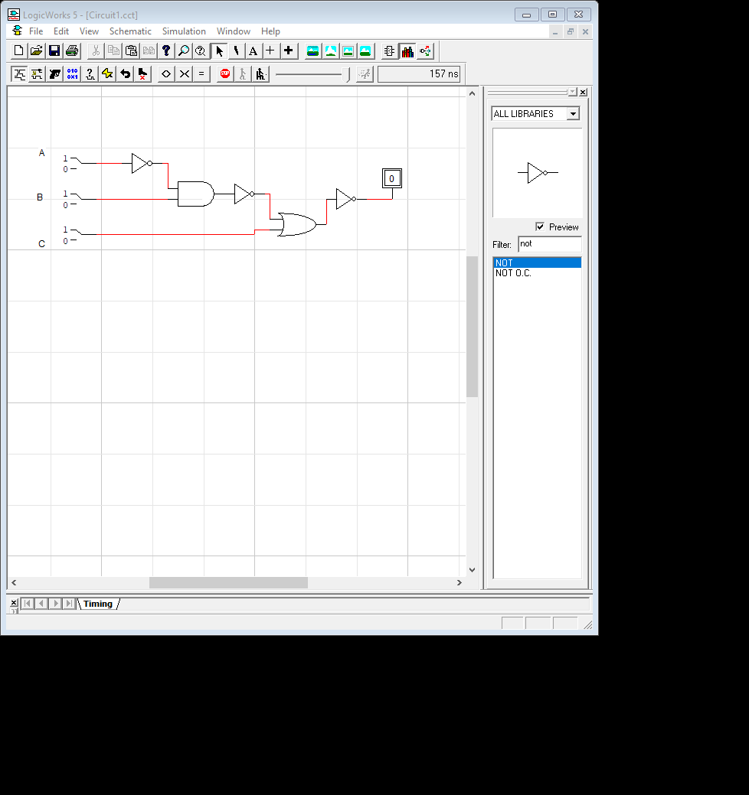

Boolean Expression: ((A~.B)~+C)~

**4**. Draw a circuit diagram corresponding to the following Boolean expression and implement it.

**Circuit # 1**: Boolean Expression: (A + B) . (B + C)

**Truth table** **Circuit Diagram**

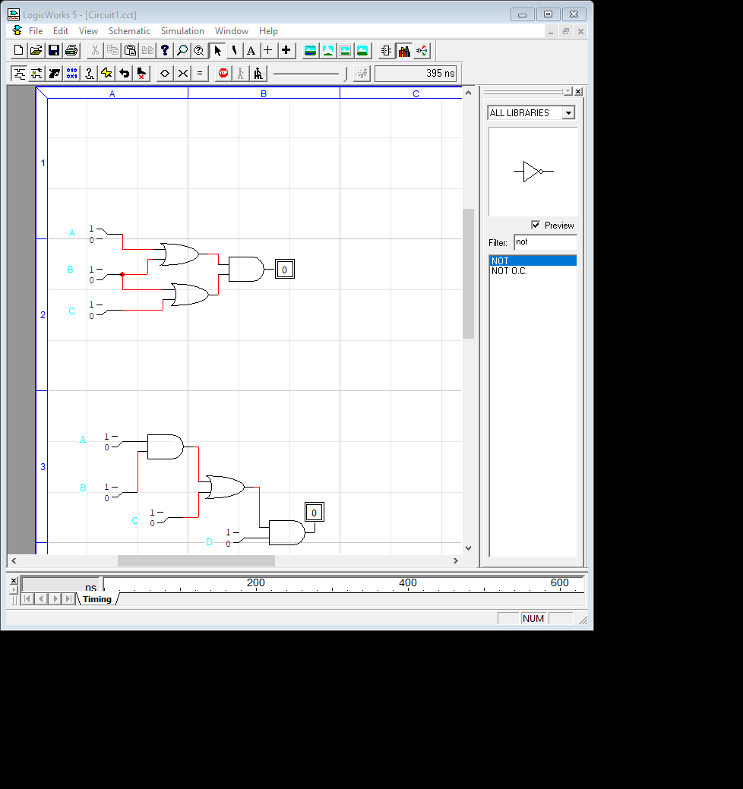

|  |  |  |  |
| --- | --- | --- | --- |
| A | B | C | X |
| 0 | 0 | 0 | 0 |
| 0 | 0 | 1 | 0 |
| 0 | 1 | 0 | 1 |
| 0 | 1 | 1 | 1 |
| 1 | 0 | 0 | 0 |
| 1 | 0 | 1 | 1 |
| 1 | 1 | 0 | 1 |
| 1 | 1 | 1 | 1 |

**Circuit # 2**: Boolean Expression: (AB + C)D

|  |  |  |  |  |
| --- | --- | --- | --- | --- |
| A | B | C | D | X |
| 0 | 0 | 0 | 0 | 0 |
| 0 | 0 | 0 | 1 | 1 |
| 0 | 0 | 1 | 0 | 0 |
| 0 | 0 | 1 | 1 | 1 |
| 0 | 1 | 0 | 0 | 1 |
| 0 | 1 | 0 | 1 | 0 |
| 0 | 1 | 1 | 0 | 1 |
| 0 | 1 | 1 | 1 | 1 |
| 1 | 0 | 0 | 0 | 0 |
| 1 | 0 | 0 | 1 | 0 |
| 1 | 0 | 1 | 0 | 0 |
| 1 | 0 | 1 | 1 | 1 |
| 1 | 1 | 0 | 0 | 0 |
| 1 | 1 | 0 | 1 | 1 |
| 1 | 1 | 1 | 0 | 0 |
| 1 | 1 | 1 | 1 | 1 |

**Truth table** **Circuit Diagram**

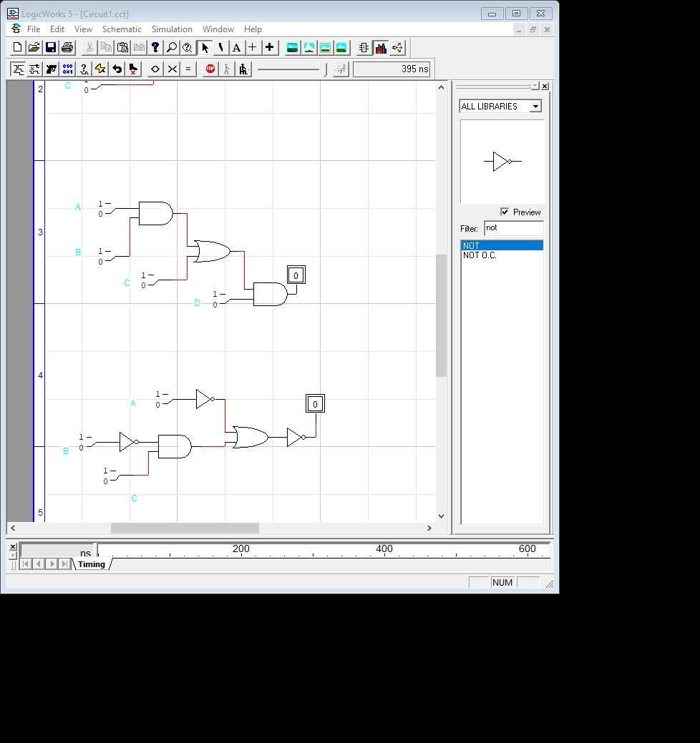

**Circuit # 3**: Boolean Expression: ((A + B~C)(A + BC))~

**Truth table** **Circuit Diagram**

|  |  |  |  |
| --- | --- | --- | --- |
| A | B | C | X |
| 0 | 0 | 0 | 1 |
| 0 | 0 | 1 | 1 |
| 0 | 1 | 0 | 1 |
| 0 | 1 | 1 | 1 |
| 1 | 0 | 0 | 0 |
| 1 | 0 | 1 | 0 |
| 1 | 1 | 0 | 0 |
| 1 | 1 | 1 | 0 |

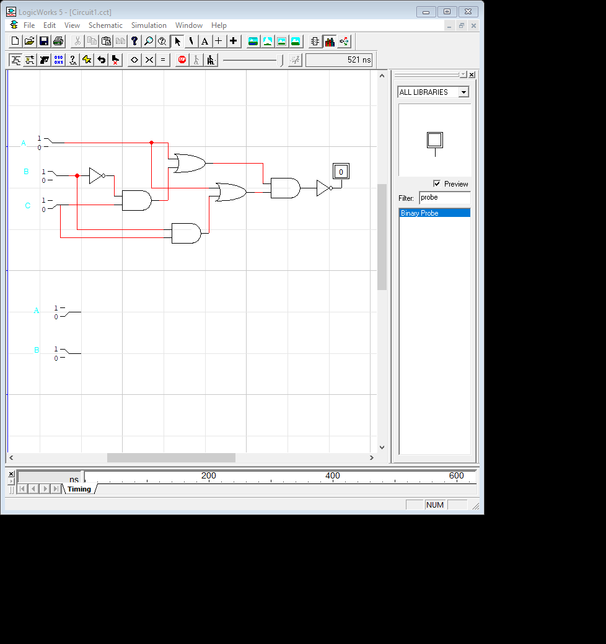

**Circuit # 4**: Boolean Expression: A’BC + AB’C + ABC’ + (ABC)’

**Truth table** **Circuit Diagram**

|  |  |  |  |
| --- | --- | --- | --- |
| A | B | C | X |
| 0 | 0 | 0 | 1 |
| 0 | 0 | 1 | 1 |
| 0 | 1 | 0 | 1 |
| 0 | 1 | 1 | 1 |
| 1 | 0 | 0 | 1 |
| 1 | 0 | 1 | 1 |
| 1 | 1 | 0 | 1 |
| 1 | 1 | 1 | 0 |

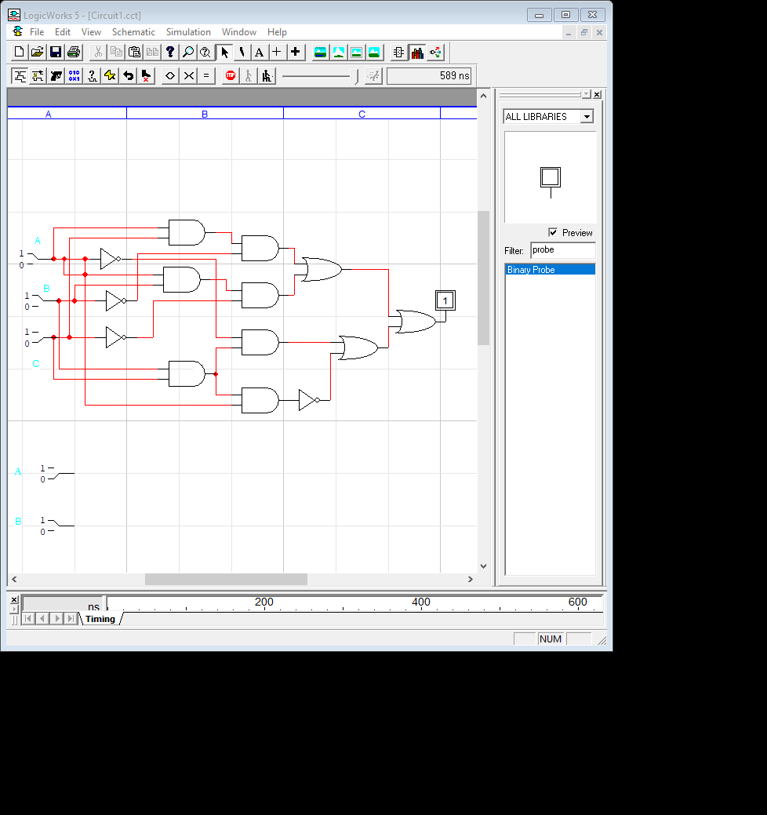

**Circuit # 5**: Boolean Expression: (A~ + BC)~

**Truth table** **Circuit Diagram**

|  |  |  |  |
| --- | --- | --- | --- |
| A | B | C | X |
| 0 | 0 | 0 | 0 |
| 0 | 0 | 1 | 0 |
| 0 | 1 | 0 | 0 |
| 0 | 1 | 1 | 0 |
| 1 | 0 | 0 | 1 |
| 1 | 0 | 1 | 0 |
| 1 | 1 | 0 | 1 |
| 1 | 1 | 1 | 0 |

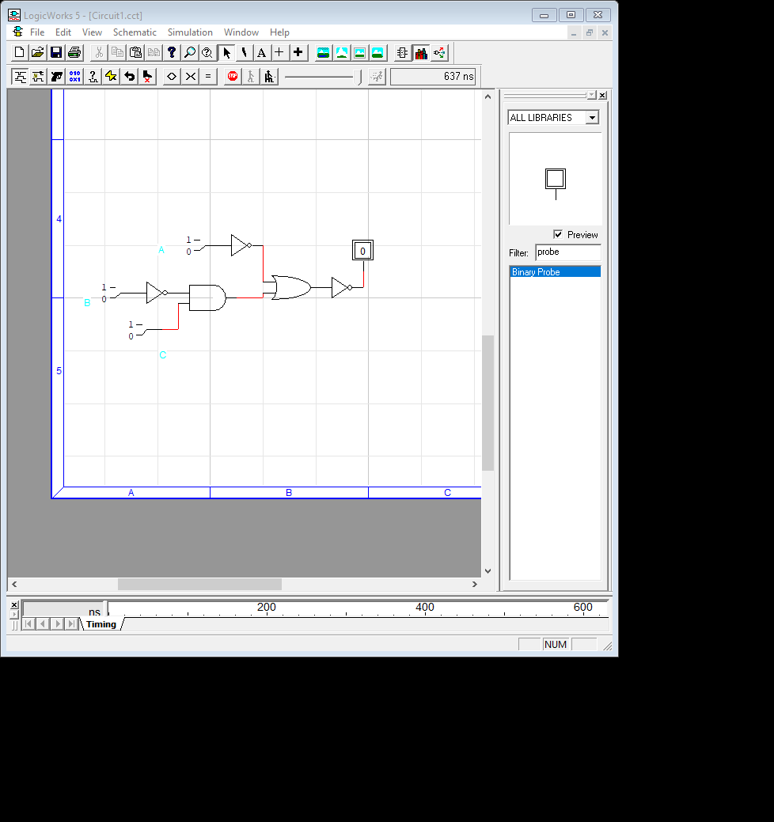

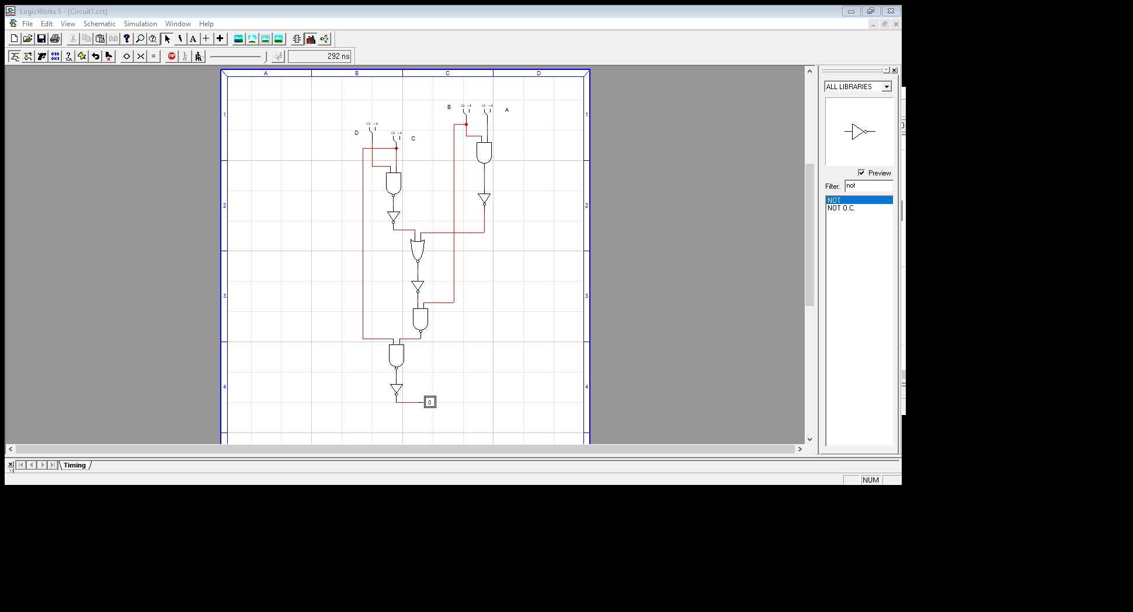

**5**. Transform the given diagram circuit to new logic diagram using NAND /NOR gates. Implement

the transformed logic circuit.

**Circuit Diagram**